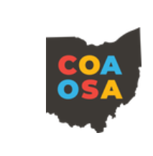
ORFF WORKSHOP FOR CREDIT (2020-2021)
ASHLAND UNIVERSITY
Instructor: Elizabeth Kowalczyk
Ew206207@ohio.edu
Cost: $200 per credit hour, payable March 13th, 2021.
Materials for all courses will need to be submitted via e-mail by 3/20.

ORFF WORKSHOP FOR 1 CREDIT: 6150 M1 – 1 hour Orff-Schulwerk
Requirements: You are required to attend 12 ½ hours of on-line COAOSA and AOSA sponsored workshops. Write and submit a one page reflection for each workshop you virtually attend or view. The reflections should communicate why the workshops reflected Orff-Schulwerk and what you took away from each workshop. Write and submit two lesson plans based on activities from the workshops you attend or view. Then write and submit a reflection on how the application of both lessons went. Describe the positives and challenges you faced when implementing in the new activities. You will need to attend a virtual ½ hour reflection session following the 3/13 workshop.

ORFF WORKSHOP FOR 1 CREDIT: 6150 P1 – 1 hour Orff-Schulwerk Embedded
Requirements: This course can only be done in conjunction with the above course. This course requires a log of 30 hours with the date and a description of your plan time. These 30 hours need to be time spent outside of the class teaching time. Planning time and outside of school are appropriate times to log your hours. These 30 hours should be time spent integrating Orff-Schulwerk into your classroom. Examples of topics appropriate to be logged: lesson plans, reflection of lesson plans, time spent researching Orff-Schulwerk ideas, or creating a sequential curriculum. Remember, these are only examples and other ideas will be accepted.
When combining with the above graduate credit option, you must attend the virtual one hour reflection following the workshop on 3/13.
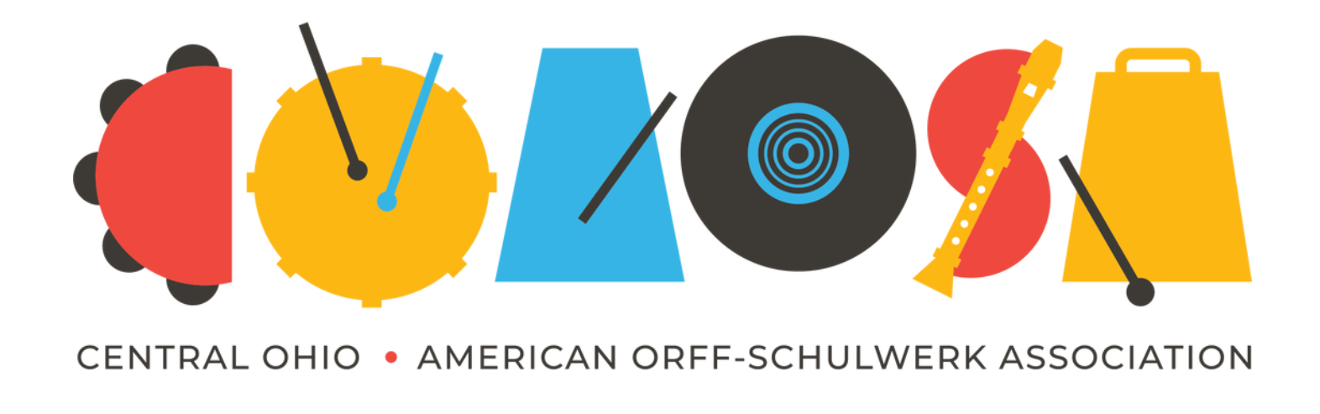
2020-2021 COAOSA Workshops
September 12th – Chapter Share
Join our Chapter Members as they share their online specialties.

October 24th – Andrea Donahoe
Meaningful Movement: Fresh ideas for teaching movement during distance learning.
February 20th – Brandi Waller-Pace and Lorelei Batislaong
Decolonizing the Music Room: Applying Decolonizing and Antiracist Approaches to Teaching Practices.
March 13th – Cyndee Giebler
Mining the Volumes! Discover hidden gems from the Music for Children Volumes. Have a soprano recorder handy and don’t forget your sense of adventure!

